ORDER OF WORSHIP
* Indicates, please stand if able.
Fifth Sunday in Lent March 26, 2023 9 am
Liturgist: Katrina McGillivray

WELCOME, PASSING THE PEACE OF CHRIST, & ANNOUNCEMENTS
*CALL TO WORSHIP (Psalm 130)
L: Come, all who are weary.
P: Here, we wait for the Lord.
L: Come, all who have turned away from God.
P: Here, we find forgiveness and healing.
L: Come, all who look for hope.
P: Here, we embrace God’s steadfast love.
L: Come, and fill your hearts with praise and thanksgiving.
P: Let us praise God!

*OPENING PRAYER (Psalm 23, Ephesians 5)
Great God of comfort and healing, we come today with many questions: “How will we survive the challenges of this day? Can we get through our moments of loss and grief? Will we be comforted when our tears flow like mighty streams?” In the midst of our questions, we hear voices of assurance and comfort. “I will put my spirit within you, and you shall live. With the Lord there is steadfast love. The Spirit of God dwells in you. You will see the glory of God.” May these voices remind us of your abiding presence, and your steadfast love. Thank you for walking with us throughout our days. In the name of Christ, we pray. Amen.
*OPENING HYMN I Will Call upon the Lord #2002

CHILDREN’S TIME Roxie Hostrawser
JOYS AND CONCERNS
PRAYER OF CONFESSION (Psalm 130, John 11)
O Lord, there are times when we are so lost we forget to look to you. Forgive us when we turn away from your love. Forgive us when we doubt our own feelings and the feelings of others. Forgive us when we forget that your Holy Spirit dwells within us. Help us see your love and your presence in our lives. Help us trust you no matter what life may bring, and help us follow you faithfully. Amen.
WORDS OF ASSURANCE (Psalm 23)
People of God, the steadfast love and redeeming power of God is with you today and always. You are forgiven. Thanks be to God!
PASTORAL PRAYER Pastor Shon
THE LORD’S PRAYER (In Unison)
Our Father, who art in heaven, hallowed be thy name. Thy kingdom come, thy will be done on earth as it is in heaven. Give us this day our daily bread. And forgive us our trespasses, as we forgive those who trespass against us. And lead us not into temptation, but deliver us from evil. For thine is the kingdom, and the power, and the glory, forever. Amen.
INVITATION TO THE OFFERING (Psalm 130)
God gives us steadfast love and abundant mercy. Now, we are invited to bring our gifts to God as tokens
of our thanksgiving and praise.
*DOXOLOGY Praise God, from Whom All Blessings Flow #95
*OFFERTORY PRAYER Pastor Shon
SCRIPTURE Deuteronomy 8:1-5
¹ Be careful to follow every command I am giving you today, so that you may live and increase and may enter and possess the land the Lord promised on oath to your ancestors. 2 Remember how the Lord your God led you all the way in the wilderness these forty years, to humble and test you in order to know what was in your heart, whether or not you would keep his commands. 3 He humbled you, causing you to hunger and then feeding you with manna, which neither you nor your ancestors had known, to teach you that man does not live on bread alone but on every word that comes from the mouth of the Lord. 4 Your clothes did not wear out and your feet did not swell during these forty years. 5 Know then in your heart that as a man disciplines his son, so the Lord your God disciplines you.
*HYMN OF PRAISE It’s Me, It’s Me, O Lord #352

MESSAGE The Power of “It Is Written” Rev. Inwha Shon
*CLOSING HYMN I Will Trust in the Lord #464

*BENEDICTION Rev. Inwha Shon
POSTLUDE Matthew Schluntz
ANNOUNCEMENTS

PRAYER REQUESTS: Please pray for people in need in our church, community, nation, and the world.
BIBLE STUDY in LENT: “Jesus in the Wild”, Sunday at 10:30 am/Wednesday at 5:45 pm.
UMCOR (United Methodist Committee on Relief): is the humanitarian relief and development arm of the
UMC and assists UMC to become involved in globally in direct ministry to persons in need. If you wish
to help those in need, please contact the office or the Pastor. A special offering will be accepted any time.
THE UNITED WOMEN IN FAITH: Annual Spring Retreat will be held on Saturday, May 6 at Pine
Lake Camp. Register by April 21. Cost is $20 ($25 after April 21) and includes lunch
WEDNESDAY CONNECTIONS: is designed for Christian Fellowship. A meal this week will be served
by Mission Outreach Team.
SEWING DAY: will be held on Wednesday, April 5, 1-4 pm
UMC CAMP SUNDAY: will be celebrating and promoting UMC Camp during worship on April 2nd.
Pancake breakfast follow. Please come support the Church Camp Scholarship program.
PALM SUNDAY: April 2, at 9 am
MAUNDY THURSDAY: April 6. Seder Meal at 6 pm
GOOD FRIDAY SERVICE: April 7, at 6 pm
EASTER SUNDAY: April 9. A whole congregation photo will be taken after service. Egg Hunt will be
following worship service.
THE YOUTH LED WORSHIP: on April 16th at 9 am.
SCRIP CARDS: When you are thinking of ideas for gift giving or personal use, consider Scrip cards.
Stop at the gathering area on Sundays or call Marcia at 715-284-3346
FELLOWSHIP: will be served by Esther Shon
USHER/GREETERS: Jim Bible and crew.
THIS WEEK AT THE CHURCH:
Sun: Mission Outreach 10:30 am
Wed: Wednesday Connections 4:45-6 pm Bible Study 5:45-6:30 pm
Pre-Con 5-6 pm Youth 6-7 pm
Confirmation Class 7-8 pm

Bible Verse of the Week: Deuteronomy 8:3
“Man does not live on bread alone but on every word that comes from the mouth of the Lord.”

Bible Trivia:
Who was permitted to walk through a field or vineyard and gather
what the farmer left after harvest time?
a. the blind and lame b. poor Israelites
c. foreigners, orphans & widows d. Israelite children
See: Deuteronomy 24:19-22

Black River Falls
United Methodist Church

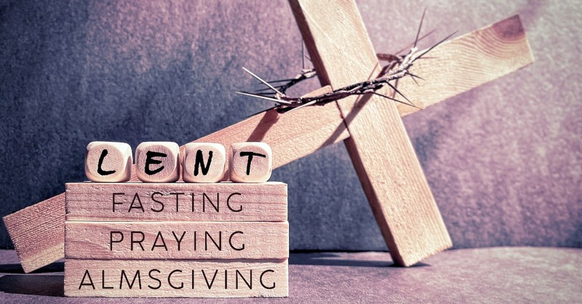

UMC Mission Statement:
"To make disciples of Jesus Christ for the transformation of the world.”

PASTOR Rev. Inwha Shon
PIANIST Matthew Schluntz
MUSIC DIRECTOR Amanda Lang

100 North Fourth Street, Black River Falls, WI. 54615
Phone: 715-284-4114 Office Hours: Monday-Thursday, 9 am-2 pm
Website: brfumc.org & Black River Falls United Methodist Church Facebook
brfumc at YouTube

